7.7 – 7.13 testing report

1. Logged in change



Before After

2. Sentence

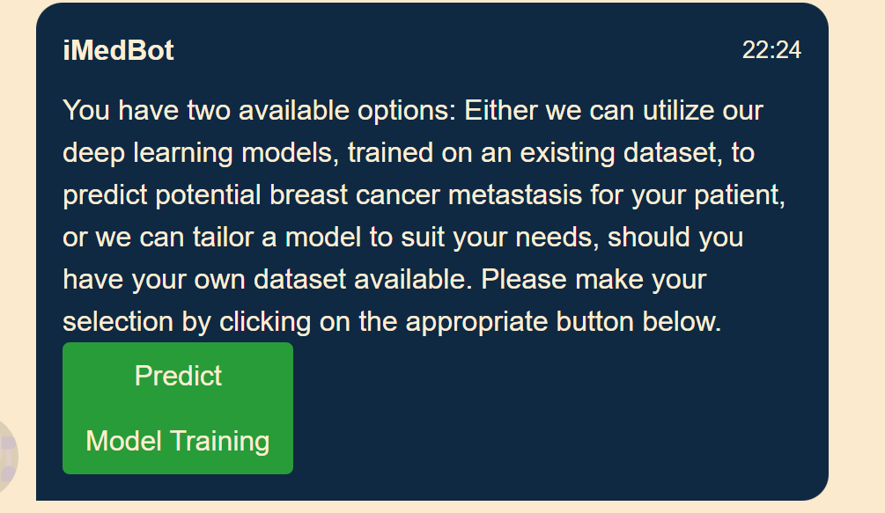

Before After

3. Display addressed, all of them.

Before After

I reconstructed the logic for show tag name function, it can display terms as a whole.

      for (i = 0; i < arr.length; i++) {

        /\*check if the item starts with the same letters as the text field value:\*/

  /\*

        if (arr[i].substr(0, val.length).toUpperCase() == val.toUpperCase()) {

          /\*create a DIV element for each matching element:\*/

  //       b = document.createElement("DIV");

  /\*make the matching letters bold:\*/

  //       b.innerHTML = "<strong>" + arr[i].substr(0, val.length) + "</strong>";

  //       b.innerHTML += arr[i].substr(val.length);

  /\*insert a input field that will hold the current array item's value:\*/

  //       b.innerHTML += "<input type='hidden' value='" + arr[i] + "'>";

  /\*execute a function when someone clicks on the item value (DIV element):\*/

  //       b.addEventListener("click", function(e) {

  /\*insert the value for the autocomplete text field:\*/

  //           inp.value = this.getElementsByTagName("input")[0].value;

  /\*close the list of autocompleted values,

              (or any other open lists of autocompleted values:\*/

  //           closeAllLists();

  //       });

  //       a.appendChild(b);

  //     }

  //   }

  //});

5. Typo

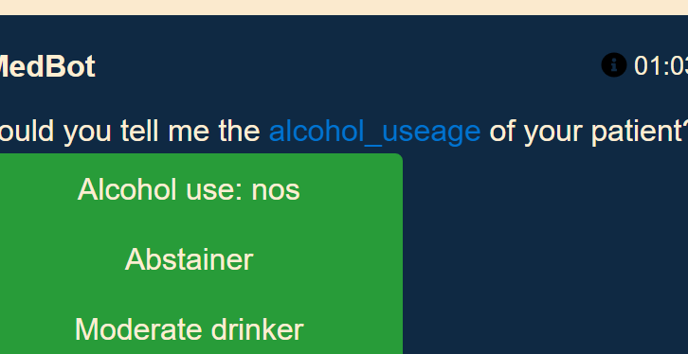

6.